Attachment no 1

DESCRIPTION OF THE SUBJECT MATTER OF THE CONTRACT

- The subject of the contract
The subject of the order is the delivery and assembly of the dedicated ICP RIE (Inductively Coupled Plasma Reactive Ion Etching) system for etching of III-V semiconductors to the Purchaser’s headquarters in accordance with the specification contained in item 5 and training of employees in accordance with the picking list contained in item 2.10.
The Contractor will provide warranty and service:
- The warranty shall be granted for the period: minimum of 24;
- The Contractor shall provide free of charge service for the duration of the warranty, the time to proceed with the repair will take place within 2 working days from the moment of reporting the defect;
- The Contractor shall provide post-warranty service for at least 15 years after the delivery;
- The Contractor shall provide access to spare parts and accessories to the system for at least 15 years after the delivery;
- The Contractor shall provide the necessary accessories and spare parts, excluding vacuum pumps and chiller, to repair the defect within no more than 5 working days after the consultant's visit and finding the defect;
- The Contractor shall provide support over the course of its business activity by telephone and e-mail in less than 48 hours;
- The Supplier shall provide technical support, including free of charge updates and possibilities to extend the device through the product life cycle;
- The Contractor shall ensure that the service technician's response time and travel time to the customer are within a maximum of 2 working days from the notification also after the warranty period has expired.
- The Contractor shall ensure the possibility of training in system operation during and after the warranty period and throughout the whole product life cycle;

Additionally, the Contractor will meet the following requirements:
  - The Contractor shall provide training at the Contractor's premises in order to demonstrate the system, present processes, and learn how to operate the system in accordance with point 10 of the specification contained in section 2;
  - The Contractor shall ensure compliance with the CE declaration.
  - Provide the user manual in Polish and English

- Scope of the subject matter of the contract
The subject matter of the order includes:
- Process chamber
- Vacuum transfer chamber with automatic wafer handling
- Vacuum cassette station for loading and storage of semiconductor wafers
- Vacuum systems
- End Point Detection system comprising Optical Emission Spectroscopy and Laser Interferometry systems
- Chiller for temperature control of the process chamber’s electrode
- PC class computer for system and process control
- Scrubber for the absorption of the gaseous process’ products from the system exhaust
- Pre-acceptance and acceptance tests on the Purchaser’s samples according to the Purchaser’s needs, including sharing the etching recipe
- Operators training (for at least two operators) including:
- Basic system operation
- Safety features of the system
- Recipe building for a time and EPD controlled processes including fully automatic processes
- Operating the EPD
- System maintenance.

- Evaluation criteria
Offers will be evaluated on a points scale with a maximum of 100 points.
Criterion | Maximum number of points (S) | Awarding method
Net Price (P) | 80 | S x Pmin/Pi
Duration of the guarantee period in moths (W) | 20 | S x Wi/Wmax

Where:
- Pi, Wi, are the net price, device warranty period, respectively,
- Pmin, Wmax, are the minimum net price of the device among all offers, the maximum warranty period of the device among all offers, respectively.
The final score will be calculated by summing up the partial components and then rounding to two decimal places.
- The deadline for completion of the order
25 weeks from the date of the contract or based on the mutual agreement, if necessary.
- Parameters
# | Component | Parameter/Function | Description
1 | Process chamber | Chamber material | - Made of aluminum ingot
 |  | Heated chamber walls | - Process chamber wall heated at least to 50°C with temperature indication in the software
 |  | Ports | - At least one viewport and ports for Optical Emission Spectroscopy (OES) and Laser Interferometry (LI)
 |  | Liner | - quartz ceramic liner with easy exchange
 |  | ICP source | - Planar source isolated with Al₂O₃ ceramic plate  - Maximum power at least 1200 W  - Automatic matching unit  - Suitable for up to 150 mm wafers
 |  | RIE source | - Source power at least 600 W  - Automatic matching unit  - Pre-selection and control of forward power or bias voltage  - Measuring and visualization of forward and reflected power, and dc bias voltage
 |  | Substrate electrode | - Suitable for wafers at least 150 mm and smaller  - With backside helium cooling with dynamic temperature control  - He backside pressure at least 5 mbar  - Anticorrosive lip seal for low gas leakage heat transfer from wafer/ carrier to the electrode  - Cooling down at least to -30°C with the use of a standard liquid chiller  - Heating at least to 200°C  - In situ substrate temperature control  - Mechanical clamping suitable for wafer thickness at least up to 1.7 mm  - Clamping for 150 mm wafers
 |  | Vacuum system | - Magnetically levitated turbomolecular pump, heated, anticorrosive  - Dry backing pump  - Base pressure ≤ 10⁻⁶ mbar
 |  | Gas box | - Gas box for at least nine gas lines  - Lines with 100 sccm MFC, particle filters, and pneumatic cut off valves  - Calibrated MFC for CH₄, H₂, O₂, CF₄, Cl₂, BCl₃, Ar, He, N₂, SiCl₄  - Cl₂, SiCl₄, and BCl₃ lines with bypasses
 |  | Process End Point Detection (EPD) system | - Optical Emission Spectroscopy (OES) system for at least 200-1100 nm range with multiwavelength analysis  - Laser Interferometry end point monitor with motorized xy stage  - Featuring automatic process stop
2 | Transfer chamber | Transfer system | - Automatic wafer handling system to move the wafers/carries from the cassette station to the process chamber and back  - Sealed non-used ports for future expansion and upgrades
 |  | Vacuum system | - Dry vacuum pump
3 | Cassette station | Cassette housing | - Temperature stable up to at least 200°C
 |  | Wafers/carriers loading | - Automatic loading and unloading  - Vacuum elevator  - Loading time ≤ 3 min
 |  | Vacuum system | - Dry vacuum pump
 |  | Through-wall installation | - Through-wall installation of the system  - At least Cassette station’s door on the clean side  - Transfer chamber + process chamber on the grey area
 |  | Number of wafers/carriers | - At least 25 wafers or 12 carriers in the cassette  - Suitable for wafers at least up to 150 mm  - Smaller wafers with the use of carriers suitable for helium backside cooling  - At least one carrier for 2” wafer  - At least one carrier for 3” wafer  - At least one carrier for 4” wafer  - At least one carrier for 3 x 2” wafers  - At least one carrier for Vigo’s specified 2/3 of 2” according to the drawing:  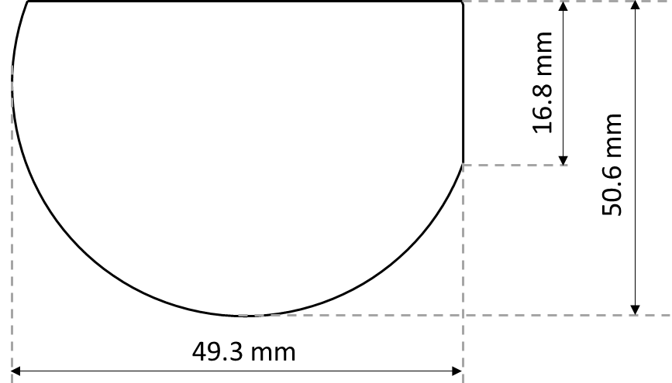
4 | Control system | PC | - PC class computer  - Equipped with Windows 10 or equivalent  - Equipped with a flat-screen monitor with at least 23” diagonal  - Equipped with a wireless keyboard and mouse
 |  | Software control | - User interface panel  - Graphical recipe builder  - Endpoint detection system control  - Data logging (ASCII file)  - Process parameters display  - Manual and automatic process control  - Software interlocks  - Parameter controlled process step execution
 |  | Hardware control | - Basic hardware safety interlocks  - Extended error diagnostics  - Remote servicing and maintenance
5 | Auxiliaries | Scrubber | - Scrubber for the absorption of gaseous process products of etching semiconductor materials with CH₄, H₂, O₂, CF₄, Cl₂, BCl₃, Ar, N₂ chemistries
 |  | Chiller | - Circulator liquid thermostat allowing cooling at least down to -30°C  - Chiller temperature set by the system software
 |  | Auxiliary systems, including vacuum systems | - Possibility of a rack mounting on top of the existing equipment
6 | Testing | Factory Acceptance Test (FAT) | - Pre-acceptance tests on the supplier site on the ordered system  - Presentation of the system’s functionality  - Presentation of plasma initiation  - Presentation of EPD functionality
 |  | Site Acceptance Test (SAT) | - Final acceptance tests after system delivery and installation  - Etching processes for III-V semiconductors based on chlorine chemistry (Cl₂, BCl₃, SiCl₄)  - Etching to GaAs substrate through all semiconductor epilayers with the use of EPD  - Etching to a chosen semiconductor epilayer with the use of EPD  - Results confirmed with the use of scanning electron microscopy (SEM)

6 Additional information
The delivered elements are to be new, not used. The system packaging is to ensure the safety of the device and system components during transport and storage. The elements will be checked for compliance with the specification included in the detailed description of the subject of the order, and in the event of non-compliance with the parameters, the elements will be returned to the Contractor. The issues of the Contractor’s liability for non-conformity of the delivered goods with the technical specification included in the detailed description of the subject of the order shall be governed by the Delivery Contract to be concluded between the Contractor and the Purchaser.

